Hollywood Golf Club
Golf Society Packages 2024

A “must play” beautiful and challenging 18 hole parkland course located in the West Midlands
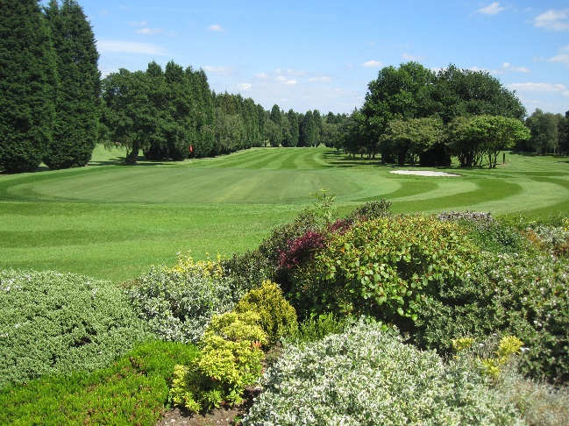
Buggies are available for hire. Competition prizes can be supplied by our Club Professional.

A great home cooked menu. A private dining
room for small and large groups (up to 120).
Golf Clinics, Starters on the tee, Score recording and leader board updates are all available.

Buggies are available for hire. Competition prizes can be supplied by our Club Professional.

PACKAGES MENU GOLF MON – THURS FRI - SUN

GOLF ONLY £25.00 £30.00

COPPICE Bacon Roll, Tea/Coffee 18 Holes Golf £29.50 £34.50

POPLARS Full Breakfast, Tea/Coffee 18 Holes Golf £32.50 £37.50

SPINNEY Bacon Roll, Tea/Coffee 18 Holes Golf £43.00 £48.00
2 Course Meal

HOLLYWOOD Full Breakfast, Tea/Coffee 27 Holes Golf £56.50 £61.50
Sandwiches & Chips
3 Course Meal

Organiser pays for food only on bookings of 16 players or more.

Winter Bookings: November to March - £5 discount on above prices.
PLEASE NOTE THAT WINTER WHEELS ARE COMPULSARY FROM OCTOBER TO MARCH
Course status may change on a daily basis during winter months so please check with the Pro Shop or on our course information line 0121 430 8544 option 5

We will ensure that you have a memorable day with us.

Information for Golf Societies

The Society Day menu is enclosed for your perusal. On the day of the competition, our Professional, Mr Jamie Hillier will advise you of the door code and confirm your reserved tee times; play will be from the yellow markers and must commence from the 1st tee only. Please let the Professional know beforehand if you will require nearest the pin and longest drive markers.

Buggies are available for hire via the Professional Shop - please pre-book as early as possible. The Professional is also happy to supply golf equipment for your prize table at very favourable, discounted rates.

It is the Society Organiser’s responsibility to ensure that all Society Members are correctly attired. No golf shoes (studs or pimples) are allowed in the Clubhouse..

Please see the attached dress code for both course and clubhouse.

The use of mobile phones is not permitted on the Course (except in the case of emergency) and in the clubhouse phones must be on silent alert and may be used discreetly. .

After telephoning to confirm your required date please return the enclosed booking form to the Secretary, at the above address, together with a non-returnable deposit of £5.00 per person or as agreed with Club Secretary.

The date you have requested will be reserved for one month until receipt of the booking form and deposit.

Menu choices must be given to the caterer 2 weeks prior to the day and FINAL Numbers for catering and Green Fees must be confirmed 48 hours prior to the event and payment for the catering & green fees to be made together prior to play commencing.

Best wishes for a pleasant day’s golf

MENU CHOICES

Spinney Package - 2 course Menu can be Starters & Main or Main and Sweet

Maximum 2 choices for society groups

Starters

Soup of the day with roll
Traditional prawn cocktail
Chicken Wings with Salad

Mains

Chicken, Chips & Peas
Roast Beef with Potatoes & Seasonal Vegetables
Spaghetti Bolognaise
Sausage & Mash in Yorkshire Pudding with Gravy & Peas
Chilli & Rice
Pie Chips & Peas
Scampi, Chips & Salad

Sweets

Cheesecake served with cream
Apple Pie & Custard or Ice Cream
After Eight Sundae

Vegetarian/Vegan Options can be organised if required.

Society Booking Form

I/We confirm the following booking for our Society event. I/We agree to pay the balance of the Green fees/Catering prior to playing and will ensure that our Members comply with the rules and dress code as laid down in the Information for Golf Societies.

Name of Society ...........................................................................

Date of Event ........................ Number of Players .................... (Approximate numbers MUST be advised 2 weeks prior to the date and FINAL numbers for catering 48 hours prior)

Golf only or Package chosen________________________________

Tee Time: Morning..............................Afternoon..............................

Organisers Details

Name (PRINT) ...............................................

Signature ……………………………… Date ……………….

Address……………………………………………………….....……………………………………

…………………………………………………………………………………………………………..

Contact telephone number .....................................................................................

E Mail Address……………………………………………………………………….

A non-returnable deposit as agreed with the Club Secretary

We use the information above to allow us to contact you regarding your society booking. We share this information with our internal Data Processors who adhere to our privacy policy

We would like to be able to correspond with you regarding future society offers and in order for us to carry out this process we require you to positively opt in by indicating below. You may choose to opt out again at anytime.

I confirm that I am happy for you to communicate with me via the following means:

Post YES /NO Email YES/NO Txt Message YES

Course Dress Code – Members & Visitors

Dear valued Members and Visitors,

Our aim at Hollywood Golf Club is to move forward with the times and stay abreast with the ever changing face of the golf industry. We recognise the need for golf clubs to “stay current” and listen to our customers’ needs.
With this in mind, we have made changes to our dress code in recent years including allowing smart jeans and trainers to be worn in the clubhouse; this is only appropriate if they are clean, smart and in good condition.
As a Private Members Golf Club however, we also recognise the importance of keeping and maintaining our standards and believe this goes hand in hand with Golfs’ traditions. We offer a fantastic experience at Hollywood Golf Club and it is our desire that an enjoyable time is had by all, whether you are a full playing member or a visitor for the day. Therefore we kindly remind you to adhere to our Dress Code.

On Course Attire: Acceptable
- Collared Shirts - Only Tailored Shorts - White socks are encouraged.
- Shirts to be tucked in at all times. (We understand during play that shirts can become untucked however please try and stay “tucked in”).
- Footwear: Golf shoes and Spikeless Golf shoes only please. No Trainers. (This is for Health & Safety purposes also).

On Course Attire: UNACCEPTABLE:
- Cargo shorts/beachwear -¾ length/drawstring trousers -Trainers
- Denim jeans -Tracksuits, football/rugby shirts/shorts
- Paramilitary clothing - Shirts without collars.
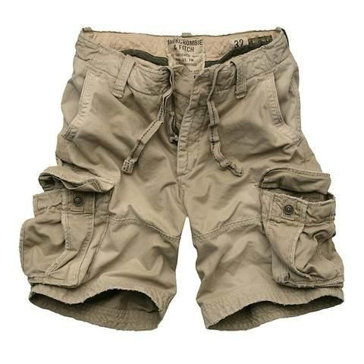
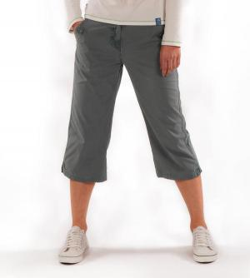
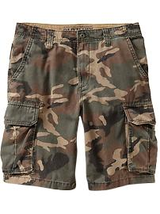

Prior to your visit with us, you are very welcome and encouraged to visit our Pro Shop Team who will assist with any concerns you may have.

